DAY 1 MINI PROJECT
Basic Network Information Analysis
Objective
The objective of this project is to collect and analyze basic network information from my system using networking commands.
This project helps understand how devices communicate inside a network and how IP addresses are used in Identity and Access Management (IAM).

Commands Used
- ipconfig
- ping google.com
- nslookup google.com

System Network Information
IPv4 Address
10.221.64.26
Explanation:
This is my private IP address used inside the local network.

Default Gateway
10.221.64.104
Explanation:
The default gateway acts as the router that connects my device to the internet.

Public IP Address
106.192.36.233
Explanation:
This is my public IP address assigned by Bharti Airtel Ltd. and visible on the internet.

DNS Information
DNS converts domain names into IP addresses.
Example:
google.com → IP address

Ping Test
The ping command was used to test internet connectivity and measure response time.
Command:
ping google.com
Result:
Successfully received reply packets from Google servers.

DNS Lookup
The nslookup command was used to identify how DNS resolves domain names into IP addresses.
Command:
nslookup google.com

Screenshots
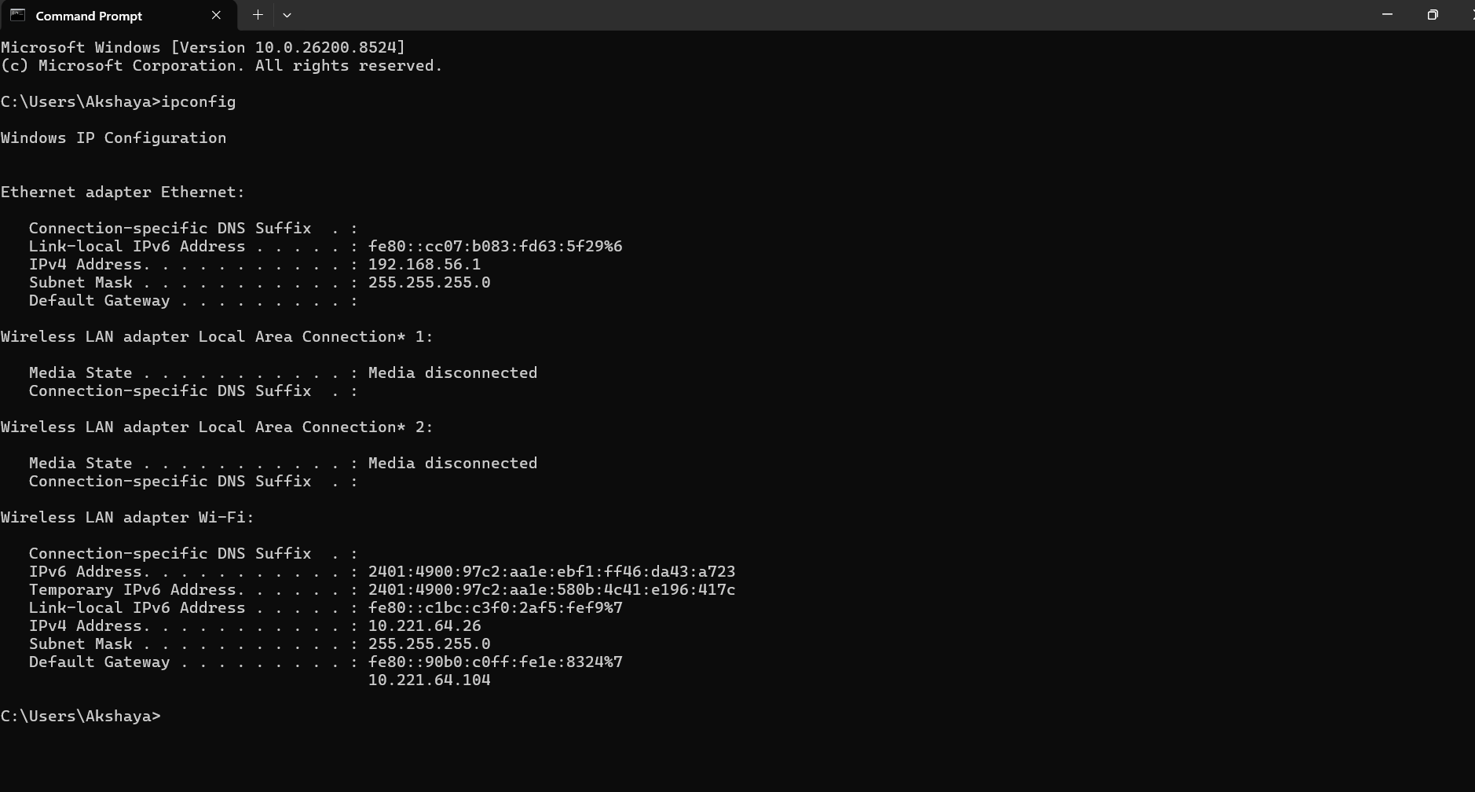
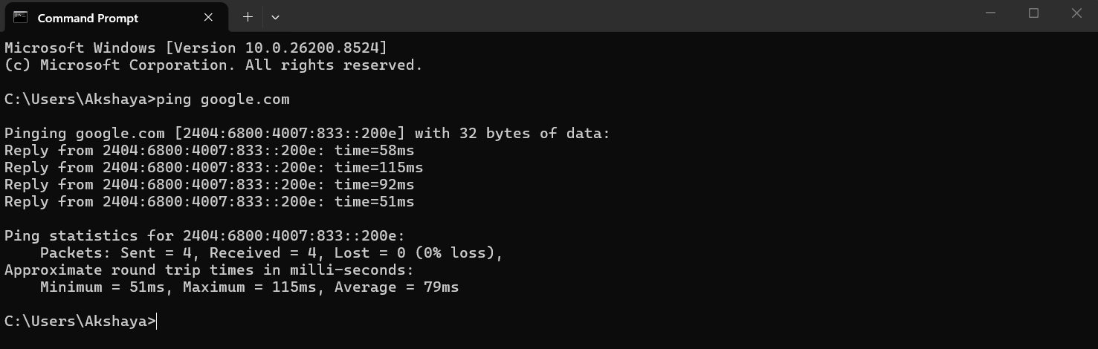
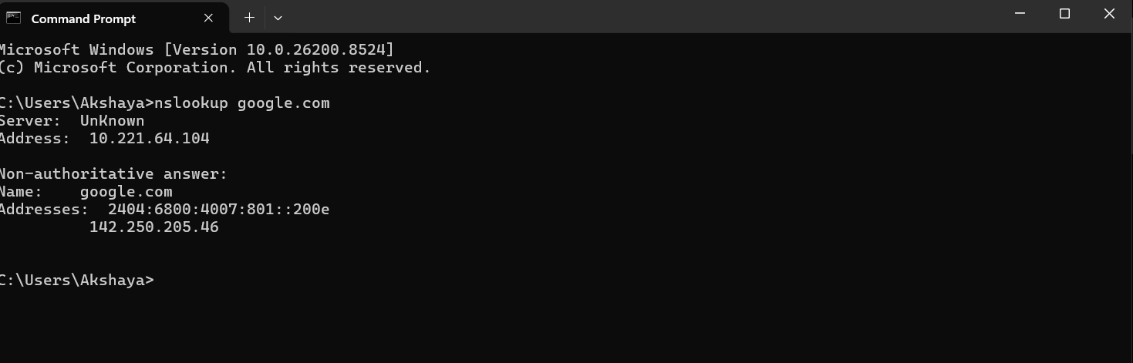
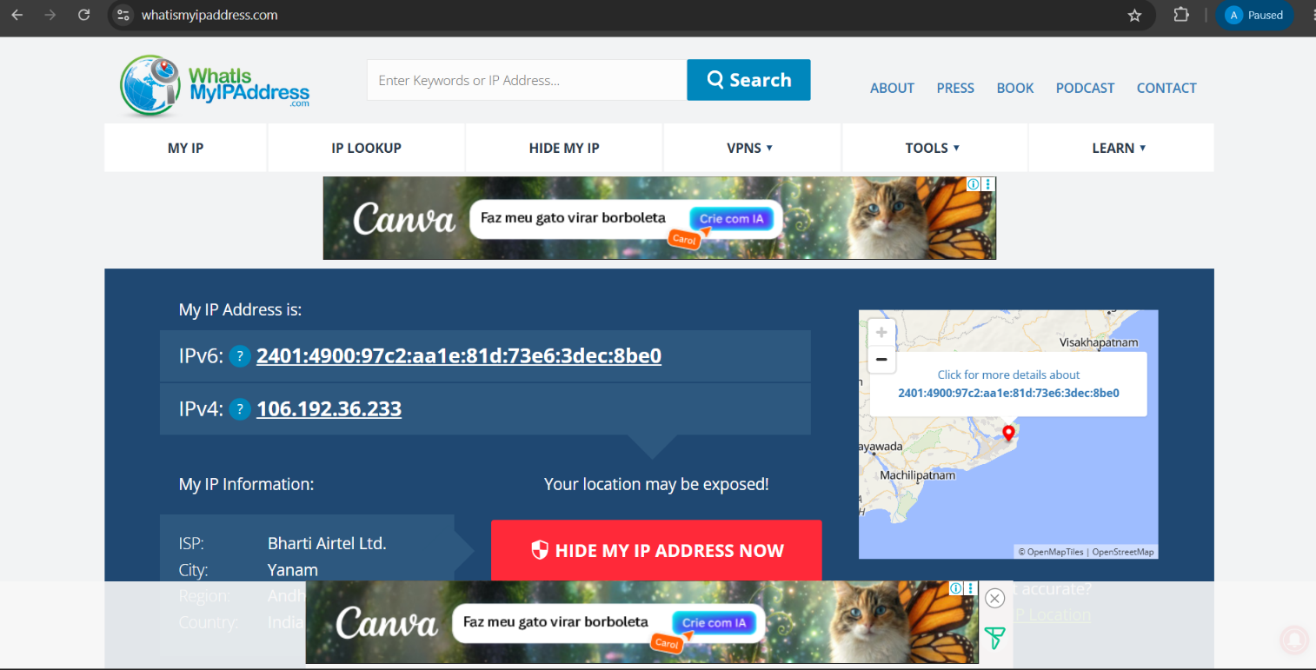

Network Flow Diagram
Laptop → Router/Gateway → Public IP → Internet

IAM Security Connection
IP addresses are important in IAM because organizations use them for:
- Login monitoring
- Geo-location tracking
- Conditional access
- Suspicious login detection
- Security auditing

Key Learning Outcome
Through this project, I learned:
- Difference between public and private IP addresses
- Basic networking commands
- Internet connectivity testing
- DNS resolution process
- Importance of IP addresses in IAM security

